**49. Growing as a Christian**

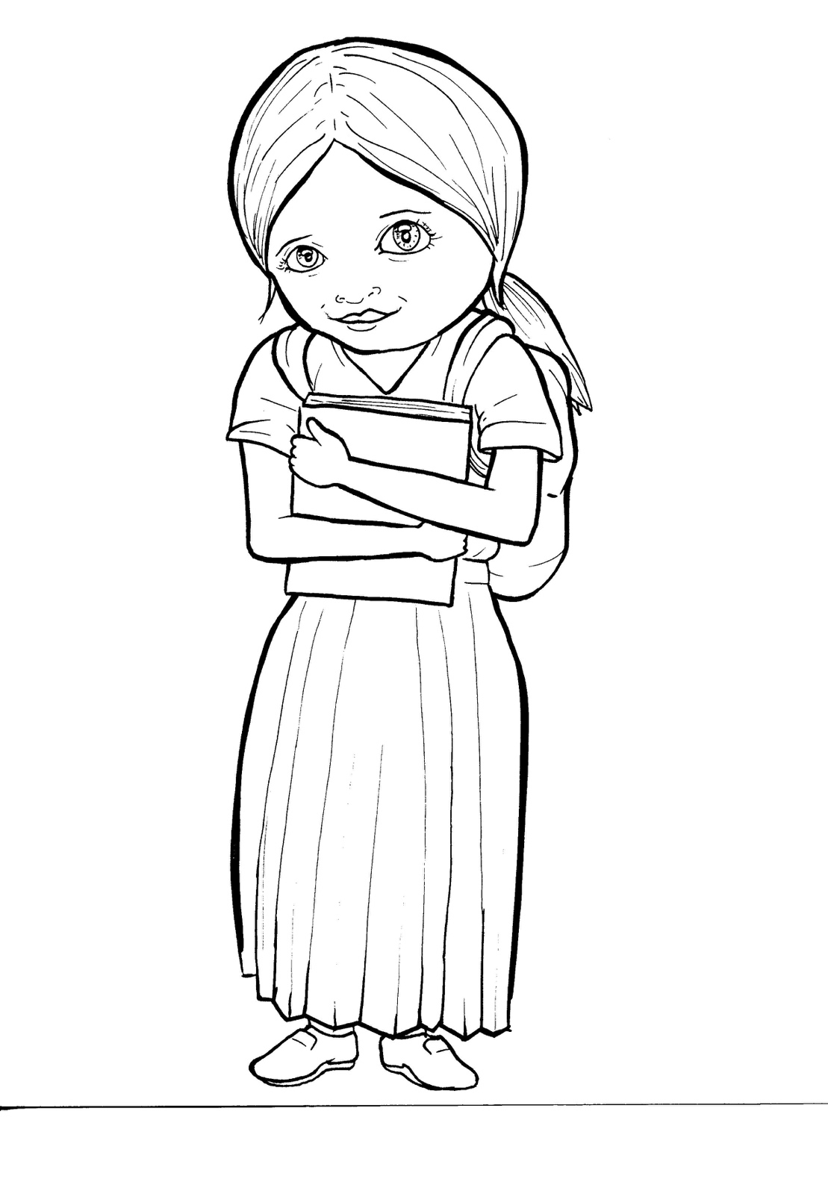Colossians 2



**Bible**

You received Christ Jesus as Lord. Live for him. Have your roots in him. Build yourselves up in him. Grow strong in what you believe.

Colossians 2:6-7

Part 1 **49. Growing as a Christian**

Words by Syllable Type

|  |  |  |  |
| --- | --- | --- | --- |
| **Closed**  short vowel  st**o**p | **Open**  long vowel  g**o** | **Silent e**  long vowel  c**a**v**e** | **Vowel Teams**  long vowels  **ea**t |
| c**a**n -**a**b-  **a**sk pl**a**nt  **e**f- -v**e**n  fr**e**sh -p**e**n  -dr**e**n -l**e**nt    h**i**m **i**f  s**i**s- w**i**ll  ch**i**l- w**i**th  pr**o**b- G**o**d  **u**p s**u**n | h**e** J**e** sus  b**e e** ven  b**e** lievers  B**i** ble  s**i** lent  g**o o** pen  m**y**  need **y**  prob ab l**y** | c**a**m**e**  t**a**k**e**s  sh**a**r**e**  th**e**s**e**  l**i**k**e** sh**i**n**e**  l**i**f**e** t**i**m**e**  th**o**s**e** cl**o**s**e** | **ai**r  r**ai**n  d**ay**  pr**ay**  pr**ay** er  be l**ie**v ers  s**ee**  m**ee**t  n**ee**d y  **ea**ch  h**ea**r  t**ea**ch es  gr**ow** kn**ow**  n**ew**  c**oo**l t**oo** |
| **Vowel Teams**  other sounds **oi**l | **R-controlled**  **or**ange | **Consonant**  **l-e** pur**ple** | **Other** |
| g**oo**d  b**oo**k  s**oi**l  with **ou**t  a b**ou**t  c**all** | st**ar**t M**ar**k  believ **er**s  sis t**er**s  teach **er**s  h**ur**ts ch**ur**ch  **or**  f**or**  sh**or**t  ef f**or**t | Bi **ble** | -**nk**, -**ng**  b**ank,** th**ing**  believ **ing**  grow **ing**  Schwa  MC900250834[1]MC900250834[1]b**a** nan **a**  **a** bout |

**.**

Part 2 **Growing as a Christian**

New Words, Rule Breakers

**Silent letters**

**kn**ow throu**gh** **Chr**istian ta**lk**

**Possessives**

Jesus**'** life

**Contractions** I**’**m = I **a**m

can**'**t = can **no**t isn**'**t = is n**o**t

**New Words**

probably through believers

**Rule Breakers**

is

to

do

who

the

you

your

eyes

give

their

there

want

what

friends

loving

other

Father

brothers

Christian

anywhere

through

Part 3 **First, the Bad News** Dividing Words into Syllables

|  |  |  |  |  |
| --- | --- | --- | --- | --- |
| **Broken into**  **syllables** | **Full Words** |  | **Broken into**  **syllables** | **Full Words** |
| 1. ra**b b**it words | MC900325566[1] |  | 3. ca**m** el words | MC900356151[1] |
| ef fort | effort |  | prob ab ly | probably |
| sis ters | sisters |  |  |  |
| Chris tian | Christian |  | 4. tur **tle** words | MC900391444[1] |
|  |  |  | Bi ble | Bible |
| 2. t**i** **g**er words | **MC900183858[1]** |  |  |  |
| e ven | even |  | 5.ant eater  compound words |  |
| Je sus | Jesus |  | with out | without |
| be lievers | believers |  | any time | anytime |
| si lent | silent |  | sun shine | sunshine |
| o pen | open |  | any where | anywhere |

**.**

|  |  |  |  |  |
| --- | --- | --- | --- | --- |
| **Broken into**  **syllables** | **Full Words** |  | **Broken into**  **syllables** | **Full Words** |
| 6. fox**es**  suffix**es** |  |  | 7. other syllable divisions |  |
| smell y | smelly |  | a way | away |
| need y | needy |  | a bout | about |
| pray er | prayer |  |  |  |
| teach er | teacher |  |  |  |
| church es | churches |  |  |  |
| grow ing | growing |  |  |  |
| believ ing | believing |  |  |  |
| closed | closed |  |  |  |
| called | called |  |  |  |

Part 4 **Growing as a Christian** Easy Read English

A new Christian is like a fresh plant that needs air, sunshine, soil, and rain. Without these, it will not grow. Believers need to do this to grow:

1. Pray
2. Read the Bible
3. Meet with other Christians
4. Give to others
5. Tell the Good News

You talk to God through prayer. Pray to God anywhere, anytime. Pray with your eyes open or closed. God can even hear silent prayers. Isn’t that cool?

God talks to you through the Bible. Read it each day. Start in Mark. This short book tells about Jesus’ life.

Christians need to be with their believing brothers and sisters. If you can’t go to church, ask God for Christian friends and Bible teachers.

God’s heart is to give to those in need. Churches help the needy, and you can too. Open your eyes to see hurts. What can you share with others?

There are probably children in your life who do not know God. Tell your friends, “Jesus came into my life! Want to meet him?” This is called the “Good News.”

Growing takes time and effort. God is your loving Father. He will teach you and help you grow up.

**Questions**

1. How is a new Christian like a plant?
2. What does a new Christian need to grow?
3. How many ways are you growing?
4. What part of growing do you need help with?

**Prayer:**

Dear Lord Jesus,

I love you. I want to grow as a Christian. I want you to be proud of me. Please help me grow to be a good disciple. Help me to get what I need to grow. Thank you.

MC900211482[1]Amen

Write in the hand the five ways

to grow as a Christian.

It will spell I GROW.

**I** will... pray

**G** ive

**R** ead my Bible

**O** bey and tell

**W** orship at church

**Growing as a Christian** Phrased for Fluency

A new Christian is like

a fresh plant that needs air**,** sunshine**,** soil**,** and rain**.**

Without these**,** it will not grow**.** Believers need to do this

to grow**:** 1) Pray

2) Read the Bible

3) Meet with other Christians

4) Give to others

5) Tell the Good News

You talk to God through prayer**.**

Pray to God anywhere**,** anytime**.** Pray with your eyes open

or closed**.** God can even hear silent prayers**.** Isn**’**t that cool**?**

God talks to you through the Bible**.** Read it each day**.** Start in Mark**.**

This short book tells about

Jesus**’** life**.** Christians need to be with their believing

brothers and sisters**.** If you can**’**t

go to church**,**  ask God

for Christian friends

and Bible teachers**.** God**’**s heart

is to give to those in need**.** Churches help the needy**,**

and you can too**.** Open your eyes

to see hurts**.** What can you share with others**?** There are probably children in your life who do not know God**.** Tell your friends**, “**Jesus came into my life**!** Want to meet him**?”** This is called

the **“**Good News**.”** Growing takes time and effort**.** God is your loving Father**.** He will teach you

and help you grow up**.**

Part 5  **49. Growing as a Christian** Vocabulary

|  |  |
| --- | --- |
| 1. establish (**e**s - T**A**B - l**i**sh):  to begin something | 2. abound (a - BOUND):to be filled with |
| 3. dwell (dw**e**ll): to live in | 4. admonish(ad - MON - ish):to remind |
| 5. spiritual (SPIR – it – u- al):about God or heaven | 6. steadfast (ST**EA**D- f**a**st):  to firmly keep going |

**49. Growing as a Christian**

Colossians 2:6-7; 16-17; 4:2a World English Bible (WEB)

As therefore you received Christ Jesus, the Lord, walk in him, rooted and built up in him, and established in the faith, even as you were taught, abounding in it in thanksgiving.

Let the word of Christ dwell in you richly; in all wisdom teaching and admonishing one another with psalms, hymns, and spiritual songs, singing with grace in your heart to the Lord.

Whatever you do, in word or in deed, do all in the name of the Lord Jesus, giving thanks to God the Father, through him.

Continue steadfastly in prayer, watching in it with thanksgiving.